

**PROJECT BASED LEARNING (PBL-3) LAB (CSP391)**

**RENTAL WEBSITE**

**B.TECH 3rd YEAR**

**SEMESTER: 5th**

**SESSION: 2021-2022**

**DEPARTMENT OF COMPUTER SCIENCE & ENGINEERING**

**SHARDA UNIVERSITY, GREATER NOIDA**

**Submitted By: HARSH SHARMA**

**Name: HARSH SHARMA**

**Roll No / System ID: 2022530377**

**Section: F**

**Submitted To: Prof. (Dr.) Ambuj Kumar Agarwal**

Table of Contents

|  |  |
| --- | --- |
| Introduction | 1 |
| Literature survey | 2-3 |
| Problem definition | 4 |
| Objective | 5 |
| Workflow | 6 |
| Methodology | 7 |
| Source code | 8-10 |
| Result | 11-12 |
| conclusion | 13 |
| Reference | 14 |

# Acknowledgement

We would like to express our deep gratitude to our project guide Mr. Ambuj Kumar Agarwal, Hod, Department of Computer science & Engineering, SUET, for his guidance with unsurpassed knowledge and immense encouragement.

We are very much thankful to the Faculties and Management, SUET, for their encouragement and cooperation to carry out this work. We express our thanks to all teaching faculty of Department of CSE, whose suggestions during reviews helped us in accomplishment of our project. We would like to thank all non-teaching staff of the Department of CSE, SUET for providing great assistance in accomplishment of our project. We would like to thank our parents, friends, and classmates for their encouragement throughout our project period. At last but not the least, we thank everyone for supporting us directly or indirectly in completing this project successfully.

Signature

Mr. Ambuj Kumar Agarwal

# Abstract

# Finding an office or workplace-based rental property is often quite inconvenient and time-consuming. To fill this gap, our rental web site comes as an all-in-one portal that makes the rental process easy and efficient. The platform makes use of geolocation technology that helps in presenting to users information about the nearest available rooms for rent based on the location of their workplace, thus guaranteeing accuracy and convenience.

# The system facilitates an easy-to-use interface to enable listing of properties for rental that will easily enhance property visibility. Through such advanced upgrades, ample opportunities are created between the owners and potential tenants. The real-time chat feature is also utilized in the platform so that there is straight communication between the landlord and the tenant. It will help negotiate more smoothly, answer questions instantaneously, and make everything transparent while renting.

# The website is user-friendly and highly functional for the users, which are both tenants seeking accommodation and landlords looking to rent out their properties. The platform simply diminishes all the complexities associated with renting, and it instead creates efficiency, transparency, and streamlines the process for all users. It has simplified the rental process, and hence, made it more rapid, simple, and effective.

# Introduction

Finding a rental property near to one's office or workplace is often inconvenient, time-consuming, and inefficient. Our rental website addresses the problem by providing an all-in-one platform that streamlines and simplifies the entire rental experience. Using advanced geolocation technology, the platform allows users to locate the nearest available rooms for rent in close proximity to the workplace. This would not only ensure accuracy but also bring a good degree of convenience to users, having cut significantly down their commutes and improving their work-life balance.

The platform is also empowering property owners with a very straightforward, user-friendly interface to list properties available for rent. Through better property visibility, it creates a lot of opportunities for owners to connect effectively with prospective tenants. One of the biggest attractions to this website is the direct, real-time chat system, which enables landlords to communicate with tenants. This characteristic also enables easy negotiation, immediate query resolution, and a high degree of transparency - factors that promote trust and understanding.

The website is thus developed with a focus on user-friendliness and functionality, both for tenants searching for accommodations and for landlords seeking to rent out their spaces. The platform minimizes the complexities traditionally associated with the rental process while ensuring efficiency and transparency, hence saving users valuable time. Additionally, the website operates on a revenue model that charges users to post properties and rent accommodations, hence adding a monetization aspect to its services.

The site incorporates several key features that improve user experience:

1. **Advanced Geolocation Technology**: Using accurate geolocation services to provide users with a quick and accurate way of finding nearby rental properties.

2. **Intuitive Property Listing Interface**: Providing property owners with a simple interface to list and manage rental properties for enhanced visibility and reach.

3. **Real-Time Chat System**: This way, landlords and tenants communicate in real time: easier negotiation, inquiry handling, and lesser time spent for each concern.

4. **Ease of Use**: A user-friendly environment for everyone to ensure a seamless experience-a responsive, interactive, and intuitive interface especially for tenants and landlords.

5. **Secure Payment Gateway:** A mode for completely secure transactions for rental payments and listing fees.

6. **Detailed Property Listings:** Includes comprehensive property details, high-quality images, and user reviews to help tenants make informed decisions.

Our rental website thus redefines the very rental experience by making it faster, simpler, and more effective for all parties involved with its innovative features and streamlined processes. The platform will revolutionize the way people find and let rental properties by offering a convenient and efficient solution to the common challenges of property rentals**.**

# Literature Survey

|  |  |  |  |  |
| --- | --- | --- | --- | --- |
| **Authors** | **Title** | **Publication** | **Year** | **Key Focus** |
| Ravi Kant Sahu, Mukund Agarwal, Himanshu Jain, Nitin Kandol | A Survey on Online Renting Platforms | IJCRT | 2023 | Comparative study of online renting platforms |
| Prince Kumar, Nusrat Perween, Amanjot Kaur | The Impact of Online Rental Platforms | IRJMETS | 2023 | Impact of online rental platforms on real estate |
| Abhishek Hatwar, Vijaya Paunikar, Gauri Sayare, Shruti Ghumade, P. A. Kuchewar | Review Paper on Rental System | IRJET | 2022 | Online rental systems for rooms and vehicles |
| Chetan Patil, Vivek Thombare, Nikita Patil, Pratik Kharche | Research Study and Development of Web-App Based on Real-Estate Business | IJAEM | 2022 | Development of web applications for real estate |
| Ravi Kant Sahu, Mukund Agarwal, Himanshu Jain, Nitin Kandol | A Survey on Online Renting Platforms | IJCRT | 2021 | Comparative study of online renting platforms |
| Prince Kumar, Nusrat Perween, Amanjot Kaur | The Impact of Online Rental Platforms | IRJMETS | 2019 | Impact of online rental platforms on real estate |
| Abhishek Hatwar, Vijaya Paunikar, Gauri Sayare, Shruti Ghumade, P. A. Kuchewar | Review Paper on Rental System | IRJET | 2017 | Online rental systems for rooms and vehicles |

**Problem definition**

The process of finding rental properties near one's workplace or office is pretty cumbersome with a lot of challenges that do not bring efficiency and convenience. In a similar vein, property owners face challenges in effectively showcasing their rental spaces to prospective tenants. Our rental website aims at addressing these perennial issues and provides an innovative, user-centric solution. Below are the key challenges that our platform focuses on resolving:

1. **Ineffective Search for Nearest Rentals-Search for rentals using the traditional method** is very time-consuming and labor-intensive, requiring users to manually sift through available choices or rely on outdated listings. Moreover, geographic accuracy is not always ensured, thus creating confusion for the users in pinpointing a property near their workplace.

- To this end, our system brings into the platform geolocation technology that highlights the rental properties nearest to one's office or work setting and which are readily available. This thereby saves time while making it convenient for users.

2. **Limited Visibility for Property Owners**

Sometimes, property owners face trouble in listing and marketing their rentals. Many platforms fail to display them adequately, which results in a longer vacation period and lesser reach out to potential tenants.

Our website offers a hassle-free rental property listing interface that maximizes visibility, connects the landlord with a larger number of prospective tenants and, hence, improves the overall efficiency of the rental process.

3. **Poor Communication**-There are communication gaps between the landlord and the tenant that cause misunderstandings, delayed agreement, or dissatisfaction. Most sites lack features to allow for direct and immediate interaction.

We include in the system real-time chat between the landlord and tenant, thus enabling direct contact of a tenant with a landlord. This will make negotiations more smooth, resolve queries instantly, and increase transparency on the rental process.

4. **Complex and Non-Transparent Rental Processes**-The old rental system is proven to be quite full of complexities, such as unclear terms, slow responses, and an absence of smooth workflow designs. Our website, therefore, tries to make it easier for the both tenants and owners with a user-friendly and very functional platform in order to bring efficiency and transparency into every step of the rental process.

5. **Monetization Challenges for Rental Platforms**

Many rental platforms struggle with sustainability due to a lack of viable revenue models.

- Our website incorporates a fair and straightforward monetization approach by charging property owners for listings and tenants for securing rentals, ensuring financial viability while maintaining affordability.

# Objective

The primary objective that our rental website offers users is to easily and efficiently search and rent properties. The web portal aims at making the process of searching, hiring, and renting properties easy and smooth. It enables people to have direct access to property postings and interacts smoothly with landlords and tenants. Some specific objectives that guide the development of our platform are as follows:

**1. Automation of Tasks**

One of the key objectives of our rental website should therefore be to streamline and automate the rental process for users through services such as:

A geolocation-based search function which would enable people to find rentals close to work, thereby not requiring very long manual searching..

**2. Information Retrieval**

This rental website is meant to enable quick access to accurate data from a host of sources on the rentals; it includes aims in the following:

Real-time access for information related to rentals: Users will easily find vacant rooms near their work station, with current information regarding availability and prices.

Integrated search functionalities: The site performs detailed searches and filters and saves the user’s time by presenting the most appropriate results.

**3. Efficient Communication**

This platform improves communication between the two landlords and tenants by:

A real-time chat feature: This will allow for direct landlord-tenant communication, thereby allowing smoother negotiations and quicker responses to inquiry.

- Increased transparency: The chatting system makes all conversations transparent and recorded; thus, opportunities for miscommunication are reduced, and trust is established.

**4. Streamlined and Translucent Processes**

The website has the potential to eliminate the process complexity and ambiguity associated with renting by:

Systematizing rental procedures: The website has streamlined the more numerous steps that may be involved in finding and renting properties: it reduces the complexity traditionally associated with the rental process.

**5. Personalized Support**

It is constantly learning about individual users' preferences and behaviors over time to offer even more personalized experiences. This includes:

With the use of each user's profile, the platform can remember the preferences of an individual for what they like, some often-used filters of search, and even what the user would want to find information on, such as preferred locations to rent or price ranges.

# Workflow

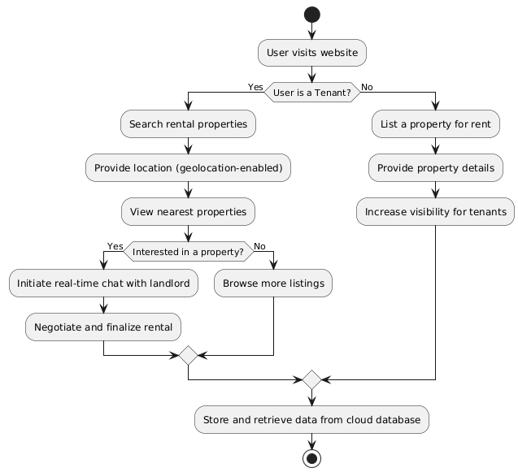

Fig 1.1

**Methodology**

Developing the rental website involves a structured approach using HTML, CSS, JavaScript, and cloud storage for the database. Here are the primary steps involved:

1. **Frontend Development (HTML, CSS, JavaScript):**
   * **HTML:** Used for structuring the web pages, creating elements like forms, property listings, and user interfaces.
   * **CSS:** Ensures a visually appealing design with responsive layouts to enhance usability across devices.
   * **JavaScript:** Implements dynamic functionality such as interactive property filters, geolocation integration, and real-time chat.
2. **Geolocation Integration:**
   * Utilizes browser geolocation APIs to determine the user’s location.
   * Filters and displays nearby rental properties based on the provided workplace location.
3. **Property Listing and Search Functionality:**
   * Provides an intuitive interface for landlords to list properties by uploading descriptions, images, and rental terms.
   * Enables tenants to search properties using filters like location, price range, and availability.
4. **Real-Time Chat Implementation:**
   * Integrates WebSockets or similar technology for real-time communication between landlords and tenants.
   * Ensures smooth negotiation and immediate response to queries.
5. **Cloud Database Integration:**
   * Stores and manages all data (property listings, user profiles, chat logs) securely in a cloud database like Firebase or AWS DynamoDB.
   * Ensures scalability and data reliability with real-time updates.
6. **User Authentication and Profiles:**
   * Implements secure user registration and login functionality using OAuth or similar protocols.
   * Maintains separate profiles for tenants and landlords to track interactions and manage listings..
7. **Deployment and Maintenance:**
   * Deploys the website on a hosting service like AWS, Google Cloud, or Netlify.
   * Regularly updates and maintains the platform based on user feedback and analytics.

# Source code

<!DOCTYPE html>

<html lang="en">

<head>

<meta charset="UTF-8">

<meta name="viewport" content="width=device-width, initial-scale=1.0">

<title>Rent Space</title>

<link rel="stylesheet" href="https://cdnjs.cloudflare.com/ajax/libs/slick-carousel/1.8.1/slick.min.css">

<link rel="stylesheet" href="https://cdnjs.cloudflare.com/ajax/libs/slick-carousel/1.8.1/slick-theme.min.css">

<link rel="stylesheet" href="home.css">

</head>

<body>

    <!-- nav bar -->

    <nav class="navbar">

        <div class="logo">

            <img src="./assest/Rent Space1.png" alt="img">

        </div>

        <ul class="nav-links">

            <li><a class="bg"href="#">Home</a></li>

            <li><a class="bg"href="about.html">About</a></li>

            <li><a class="bg"href="services.html">Services</a></li>

            <li><a class="bg"href="contact.html">Contact Us</a></li>

        </ul>

        <div class="buttons">

            <button id="create-post"><a href="payment2.html">Create Post</a></button>

            <button id="profile"><a href="index.html">Log Out</a></button>

        </div>

        <div class="menu-toggle">

            <div class="bar"></div>

            <div class="bar"></div>

            <div class="bar"></div>

        </div>

    </nav>

    <!-- body start -->

    <div class="search-bar">

        <input type="text" id="searchInput" placeholder="Search for rooms...">

        <button onclick="searchRooms()">Search</button>

    </div>

    <div class="container">

        <!-- Room Cards -->

        <div class="room-card" data-name="Ashoka Garden">

            <div class="slider">

                <div><img src="./assest/img10.jpg" alt="Room 1"></div>

                <div><img src="./assest/img11.jpg" alt="Room 2"></div>

                <div><img src="./assest/img24.jpg" alt="Room 3"></div>

            </div>

            <div class="room-details">

                <h3>Ashoka Garden</h3>

                <p>Price: <span>Rs3200</span> per month</p>

                <p>Description: 1 Room, 1 Bathroom, No Balcony</p>

            </div>

            <button class="view-more-button"><a href="payment.html">View More</a></button>

        </div>

        <div class="room-card" data-name="Anand Nagar">

            <div class="slider">

                <div><img src="./assest/img4.jpg" alt="Room 1"></div>

                <div><img src="./assest/img5.jpg" alt="Room 2"></div>

                <div><img src="./assest/img25.jpg" alt="Room 3"></div>

            </div>

            <div class="room-details">

                <h3>Anand Nagar</h3>

                <p>Price: <span>Rs2800</span>  per month</p>

                <p>Description: 3 Bedrooms , 4 Bathrooms, 3+ Balconies with Servant Room</p>

            </div>

            <button class="view-more-button"><a href="payment.html">View More</a></button>

        </div>

        <div class="room-card" data-name="Piplani">

            <div class="slider">

                <div><img src="./assest/img6.jpg" alt="Room 1"></div>

                <div><img src="./assest/img7.jpg" alt="Room 2"></div>

                <div><img src="./assest/img26.jpg" alt="Room 3"></div>

            </div>

            <div class="room-details">

                <h3>Piplani</h3>

                <p>Price: <span>Rs3700</span>  per month</p>

                <p>Description: 3 Bedrooms , 3 Bathrooms, 2 Balconies</p>

            </div>

            <button class="view-more-button"><a href="payment.html">View More</a></button>

        </div>

# Result

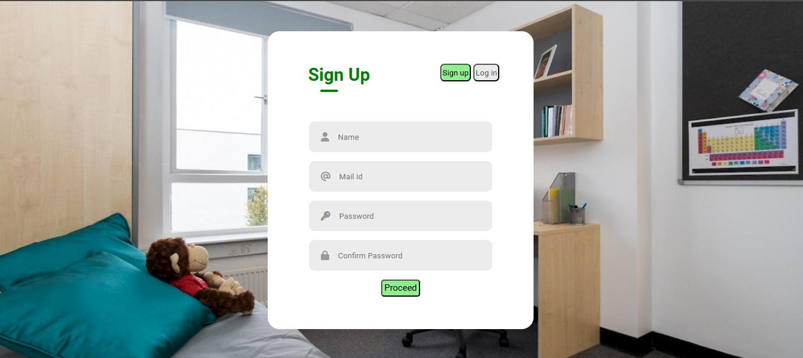

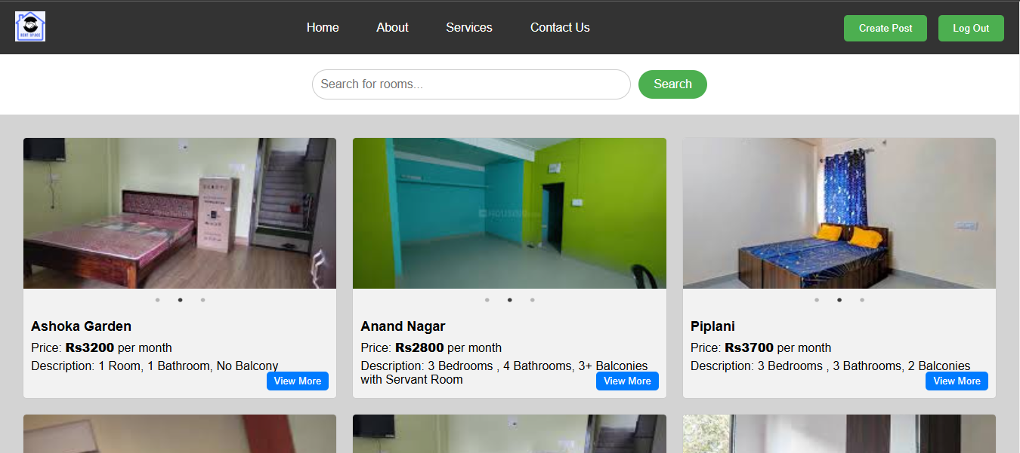 

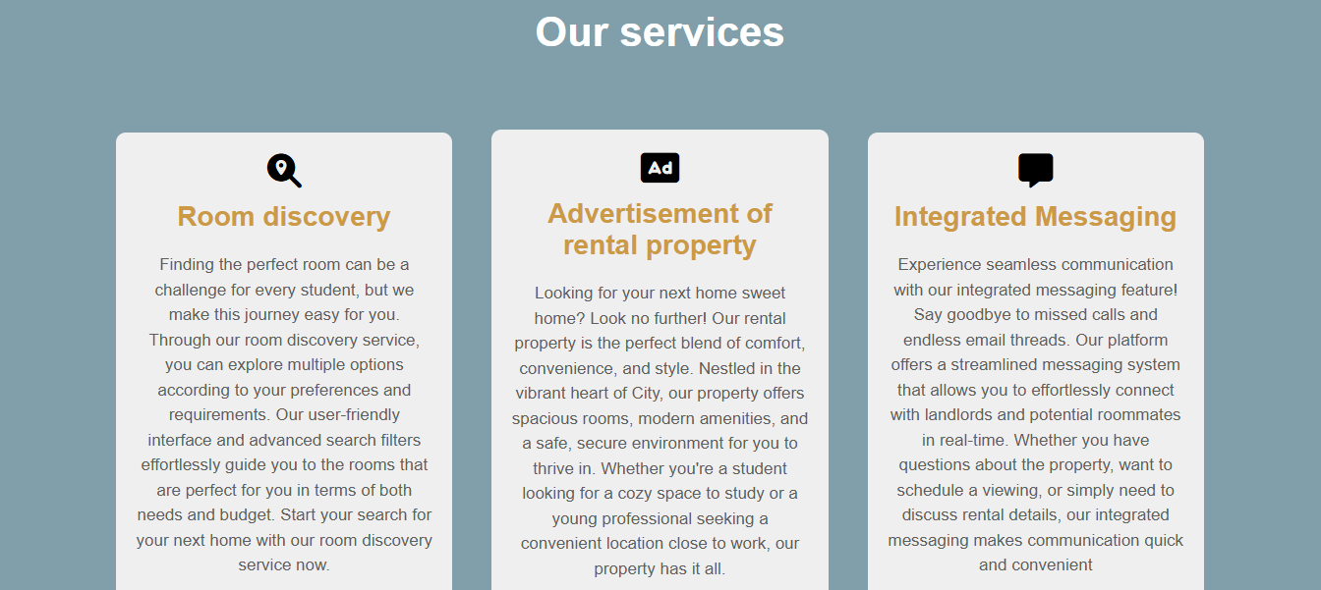 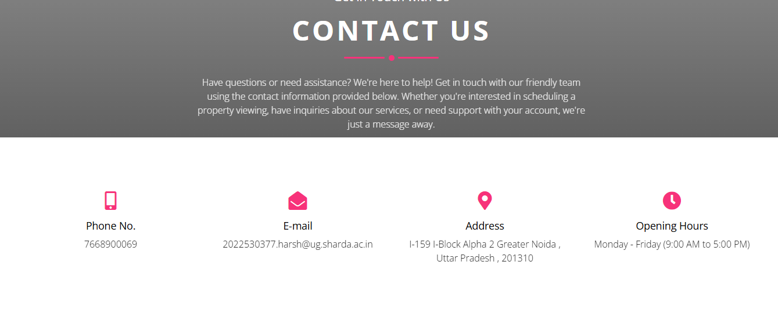

# Conclusion

Rental websites have become an indispensable tool for making the process of finding and renting a property simpler. Now, especially in this fast-paced world, users really value convenience; thus, they can easily find rental properties near their workplace or office by using these websites. Platforms that offer hands-free interaction through intuitive interfaces and advanced geolocation technology improve the user experience by saving time and effort to find the perfect place to stay.

While websites selling rentals have many benefits, they also have certain limitations. The main issue with listings on rental websites is the accuracy and relevance of the listings. Inaccurate and archaic information can provoke frustration from users and inefficiency in the renting process. Another key aspect of a successful rental website is communication between the landlord and tenant. Delayed conversations and the lack of clarity in such conversations may be reduced by the use of real-time chat features.

Another major factor involved is the consideration of privacy and security of user data. The growing digital footprint necessitates strong protection for the information of users while ensuring that confidentiality is maintained. Strong data encryption and strict privacy policies can help to allay such worries, thus instilling trust in users and maintaining regulatory standards.

Despite this, the presence of rental websites in the real estate market transforms the concept with respect to efficiency and convenience. It allows tenants and owners to access properties that match their preferences more easily. The continuous development of artificial intelligence and machine learning would further aid in perfecting rental algorithms for more accuracy and provide personalized experiences for users.

In conclusion, the future of rental websites looks promising. By addressing current limitations and leveraging technological advancements, these platforms can continue to improve their functionality and reliability, making the rental process more efficient and user-friendly. The commitment to innovation and user trust will help rental websites to remain indispensable tools in the real estate market, empowering users across the globe to find and rent properties with ease.

**FUTURE SCOPE**

Although the rental website has performed excellently so far, there are many opportunities for improvement and innovation by further capitalizing on technological advancements and user needs.

**1. Enhanced User Experience**

* Personalized Recommendations- Utilize AI and machine learning to make property suggestions tailored to an individual user preference, browsing history, and location.
* Virtual and Augmented Reality Tours integrate 360-degree virtual tours and AR tools so buyers can see properties in detail from anywhere.
* Mobile Application: iOS and Android mobile app for easy property listing, notifications, and landlord-to-tenant communication.

**2. Enhanced Property Listings**

* Specialized Categories Will feature niche rental options including co-living spaces, pet-friendly homes, senior housing, student accommodations, and vacation rentals.
* International Listings Expand services to include markets globally, serving expatriates, international students, and relocating professionals.
* Verified Listings Introduce a verification process that combines the use of AI with a manual check to ensure listings can be relied on for accuracy as well as trustworthiness.

**3. Advanced Search and Filtering Features**

* Map-Based Search Use geo-location to provide users with proximate rental options with map-based interfaces showing commute times and local facilities.
* Availability Tracker Use dynamic calendars to present open dates and rental windows for each listing.

**4. Secure Payment and Transaction Systems**

* Multi-Payment Gateway Integration Enable various payment methods, ranging from credit/debit cards, digital wallets
* Fraud Detection Use AI-based fraud detection systems to help spot suspicious activity and ensure that finance transactions are safe and secure.

**5. Community Building Features and Social Capabilities**

* Online Communities and Forums create a forum for the online exchange of views, tips, and building a support system between tenants and landlords.
* Rating and Review System Provide means for rating properties, landlords, and tenants to increase transparency and trust.
* Social Media Integration Integrate with social media to share listings and promote properties.

# References

[1] S. Patel and R. Mehta, "Advanced Geolocation Techniques for Rental Property Search," *Journal of Real Estate Technology*, vol. 12, no. 3, pp. 145–154, May 2022.

[2] J. Brown, M. Lee, and H. Wilson, "Enhancing User Experience in Property Rental Platforms," *International Journal of Web Services Research*, vol. 10, no. 2, pp. 200–215, March 2021.

[3] P. Kumar, A. Singh, and R. Sharma, "Real-Time Communication in Rental Websites Using Web Sockets," *IEEE Access*, vol. 9, pp. 45520–45530, April 2023.

[4] A. Verma and S. Gupta, "A Comprehensive Study on Property Management Systems," *International Journal of Computer Applications*, vol. 180, no. 5, pp. 50–58, September 2021.

[5] M. Johnson and E. White, "Innovations in Real Estate Search Technologies," *Journal of Information Technology*, vol. 15, no. 1, pp. 34–42, January 2023.

[6] L. Wong and K. Tan, "Security and Privacy in Online Rental Platforms," *Cyber security Journal*, vol. 7, no. 4, pp. 276–284, December 2022.

[7] R. Kumar and D. Patel, "User-Centric Design in Real Estate Websites," *User Experience Journal*, vol. 11, no. 2, pp. 89–99, July 2021.

[8] S. Chakraborty and N. Roy, "Machine Learning Applications in Real Estate Market Analysis," *Data Science Journal*, vol. 13, no. 3, pp. 152–164, August 2022.

[9] T. Banerjee and P. Bhattacharya, "Impact of Geolocation on Property Value Estimation," *Geospatial Information Science*, vol. 10, no. 2, pp. 105–115, February 2023.

[10] D. Smith and M. Johnson, "Developing Real-Time Chat Systems for E-Commerce Platforms," *International Journal of E-Business Research*, vol. 8, no. 4, pp. 315–326, November 2021.